A project report on

HIRE AND BUILD

Submitted in partial fulfillment of the requirement for the award of

M.C.A Degree

of

KANNUR UNIVERSITY

By

SAYOOJ.P

Register No:B6GMCA2105

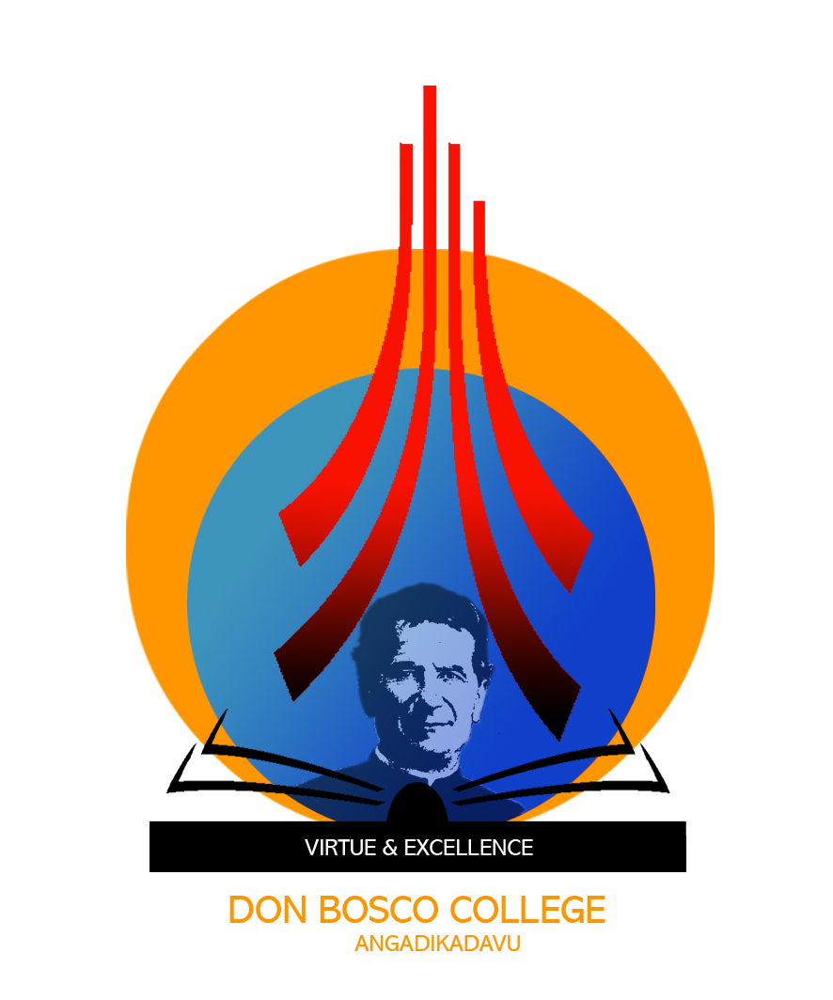

Don Bosco College
Angadikadavu, Kannur – 670 706

Kerala

2019

